Nautiz October 2023 price list

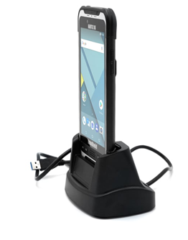
Nautiz X6 complete package:
- Camera, Bluetooth, Battery, GPS
- Desk cradle (desktop dock)
- AndrOvin software
- LF RFID tags reader ISO 11784/11785
- AC Adapter
- Hand strap (back)
- Belt carrying case
$3300 + taxes

Individual items:
- Nautiz X. mobile unit with AndrOvin software and tag reader: $ 3015
- Nautiz X6 Desk docking (desktop dock) – no power supply $ 165
- AC adapter for the Nautiz X6 (required with the docking) $ 75
- Nautiz X6 hand strap $ 60
- Belt carrying case with clip $ 100
Optional maintenance contracts:
- 3 year optional maintenance contract $ 440
- 5 year optional maintenance contract $ 775

